Irregular Mixed Shapes
# Source: AI Source: Provided by: [Data Path: Persons Table -> ID Column: 1, Name_En Column: Motasem Essam] -> From: [ChatGPT] on [7/25/2026]
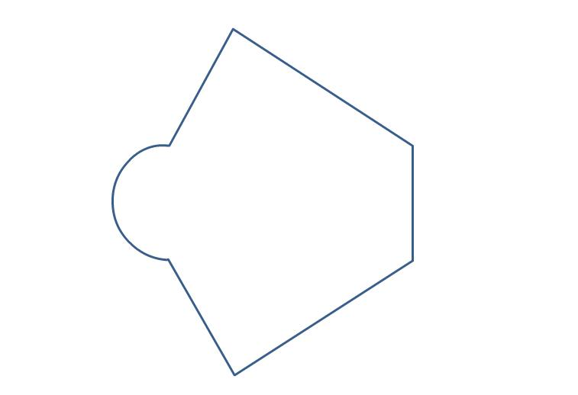
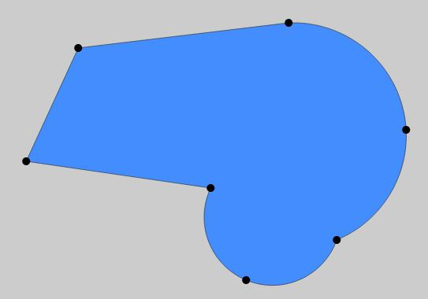
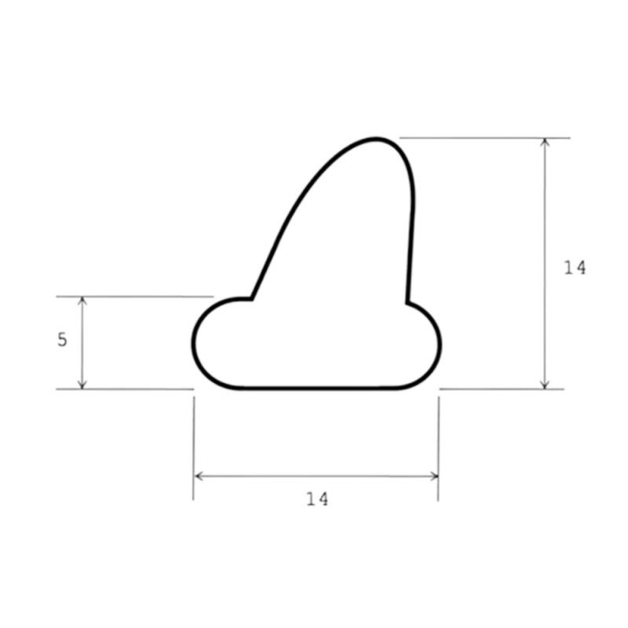
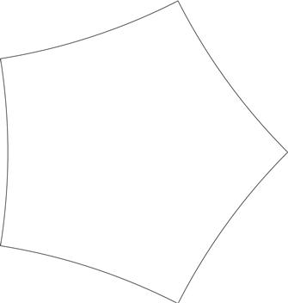

Definition
# Source: AI Source: Provided by: [Data Path: Persons Table -> ID Column: 1, Name_En Column: Motasem Essam] -> From: [ChatGPT] on [7/25/2026]
An Irregular Mixed Shape is a closed two-dimensional shape whose boundary contains both straight-line segments and curved segments, without following a regular geometric pattern.
In simple terms:
An irregular mixed shape combines polygonal and curved parts into one irregular shape.
$$\boxed{\text{Irregular Mixed ShapeStraight Boundaries}+\text{Curved Boundaries}+\text{Irregular Form}}$$

Characteristics
# Source: AI Source: Provided by: [Data Path: Persons Table -> ID Column: 1, Name_En Column: Motasem Essam] -> From: [ChatGPT] on [7/25/2026]
An irregular mixed shape typically:
- Is a 2D shape.
- Is usually closed when it represents a region.
- Contains both straight and curved boundaries.
- Does not follow a single standard geometric shape.
- May have straight and curved sections of different lengths.
- May be asymmetric.
- Can contain corners where straight and curved boundaries meet.
- Can have an irregular perimeter.
- May require multiple formulas or numerical methods to determine its area.

Examples
# Source: AI Source: Provided by: [Data Path: Persons Table -> ID Column: 1, Name_En Column: Motasem Essam] -> From: [ChatGPT] on [7/25/2026]
1. Rectangle + Semicircle
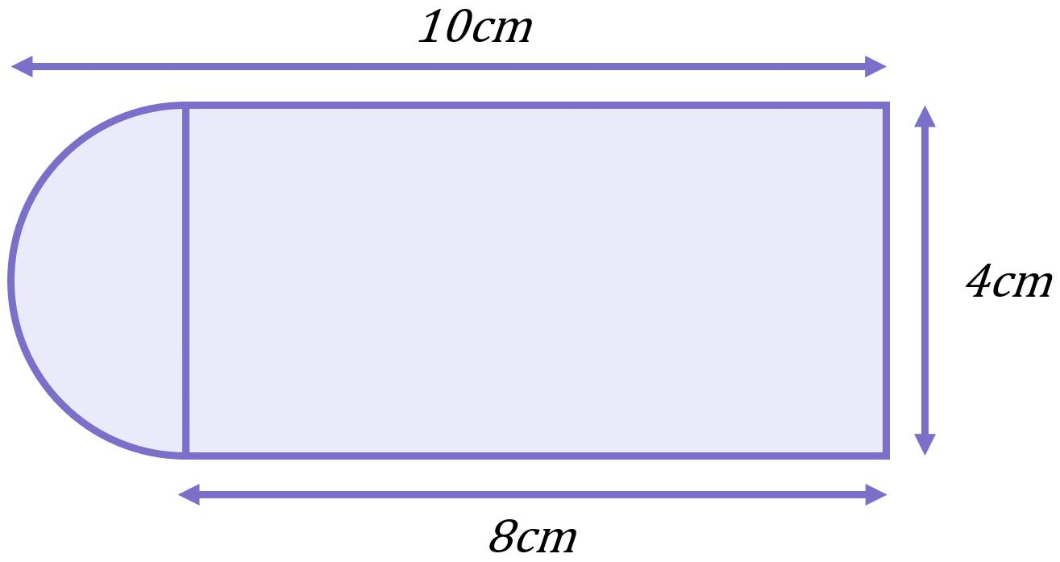
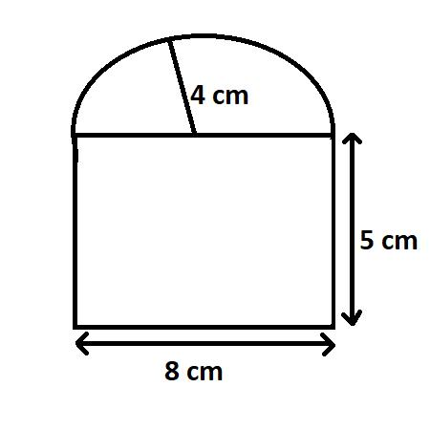
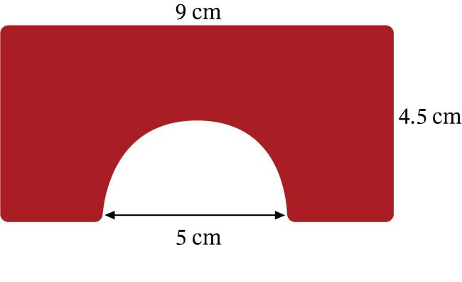
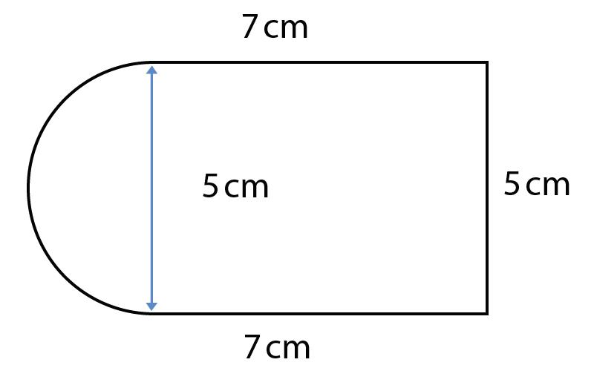
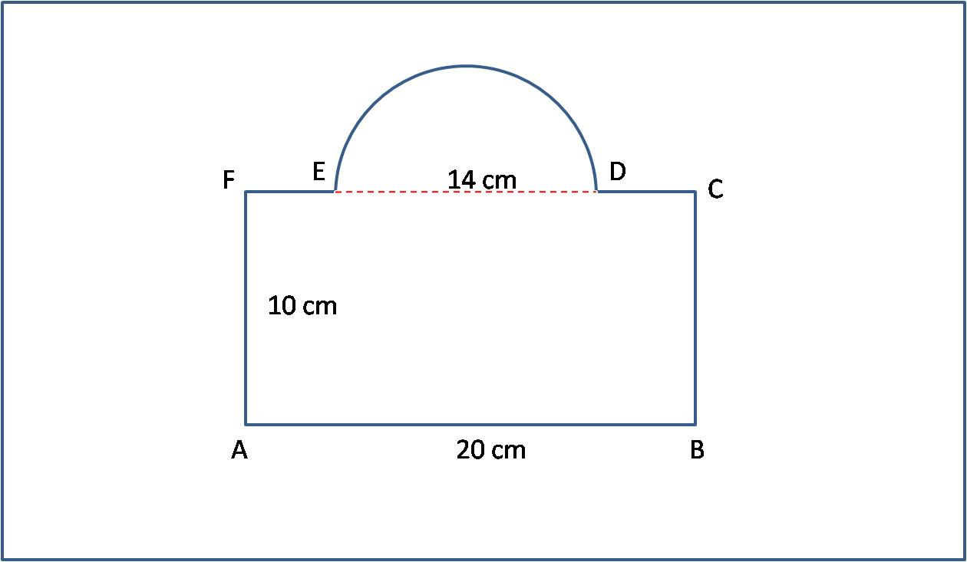
This type combines:
- Straight sides from a rectangle.
- A curved boundary from a semicircle.

2. Polygon + Circular Arc

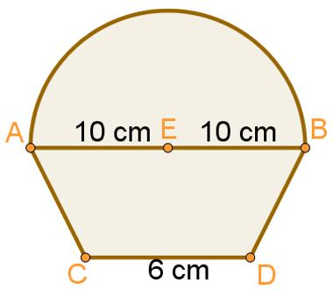

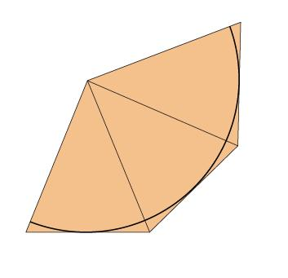
Part of the boundary consists of straight segments, while another part is a circular arc.

3. Irregular Organic Mixed Shape
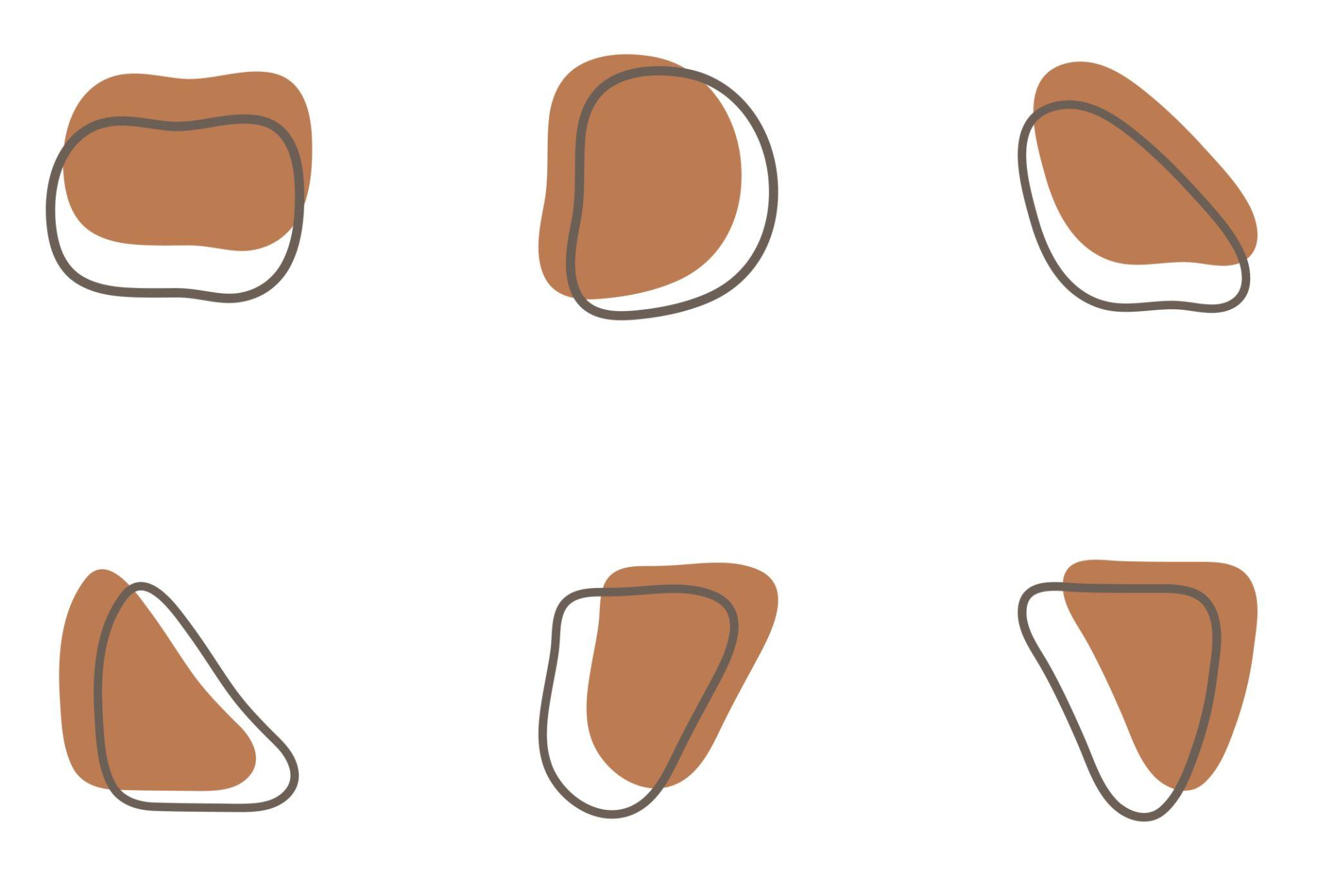
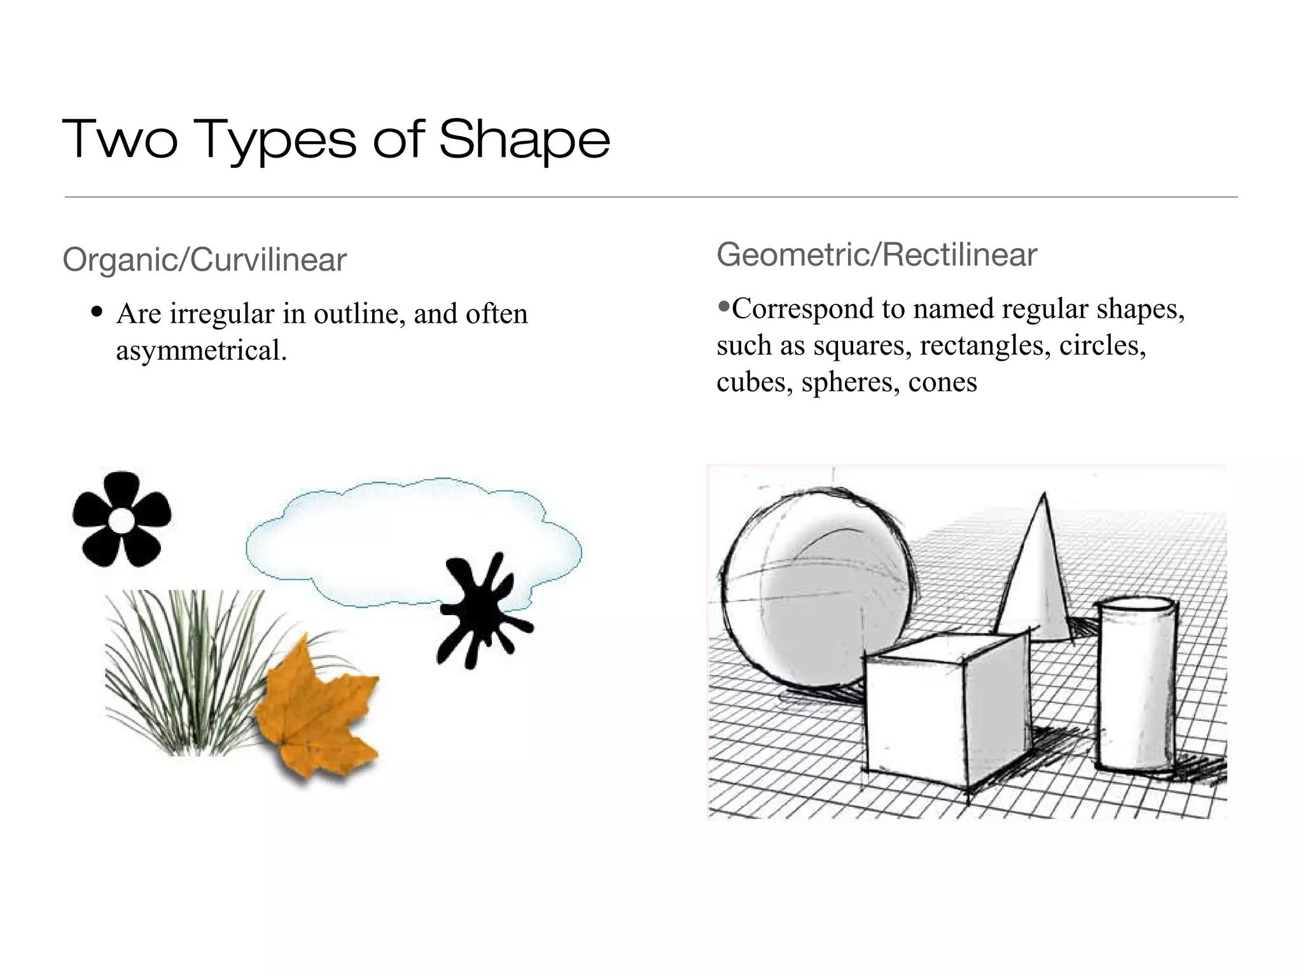
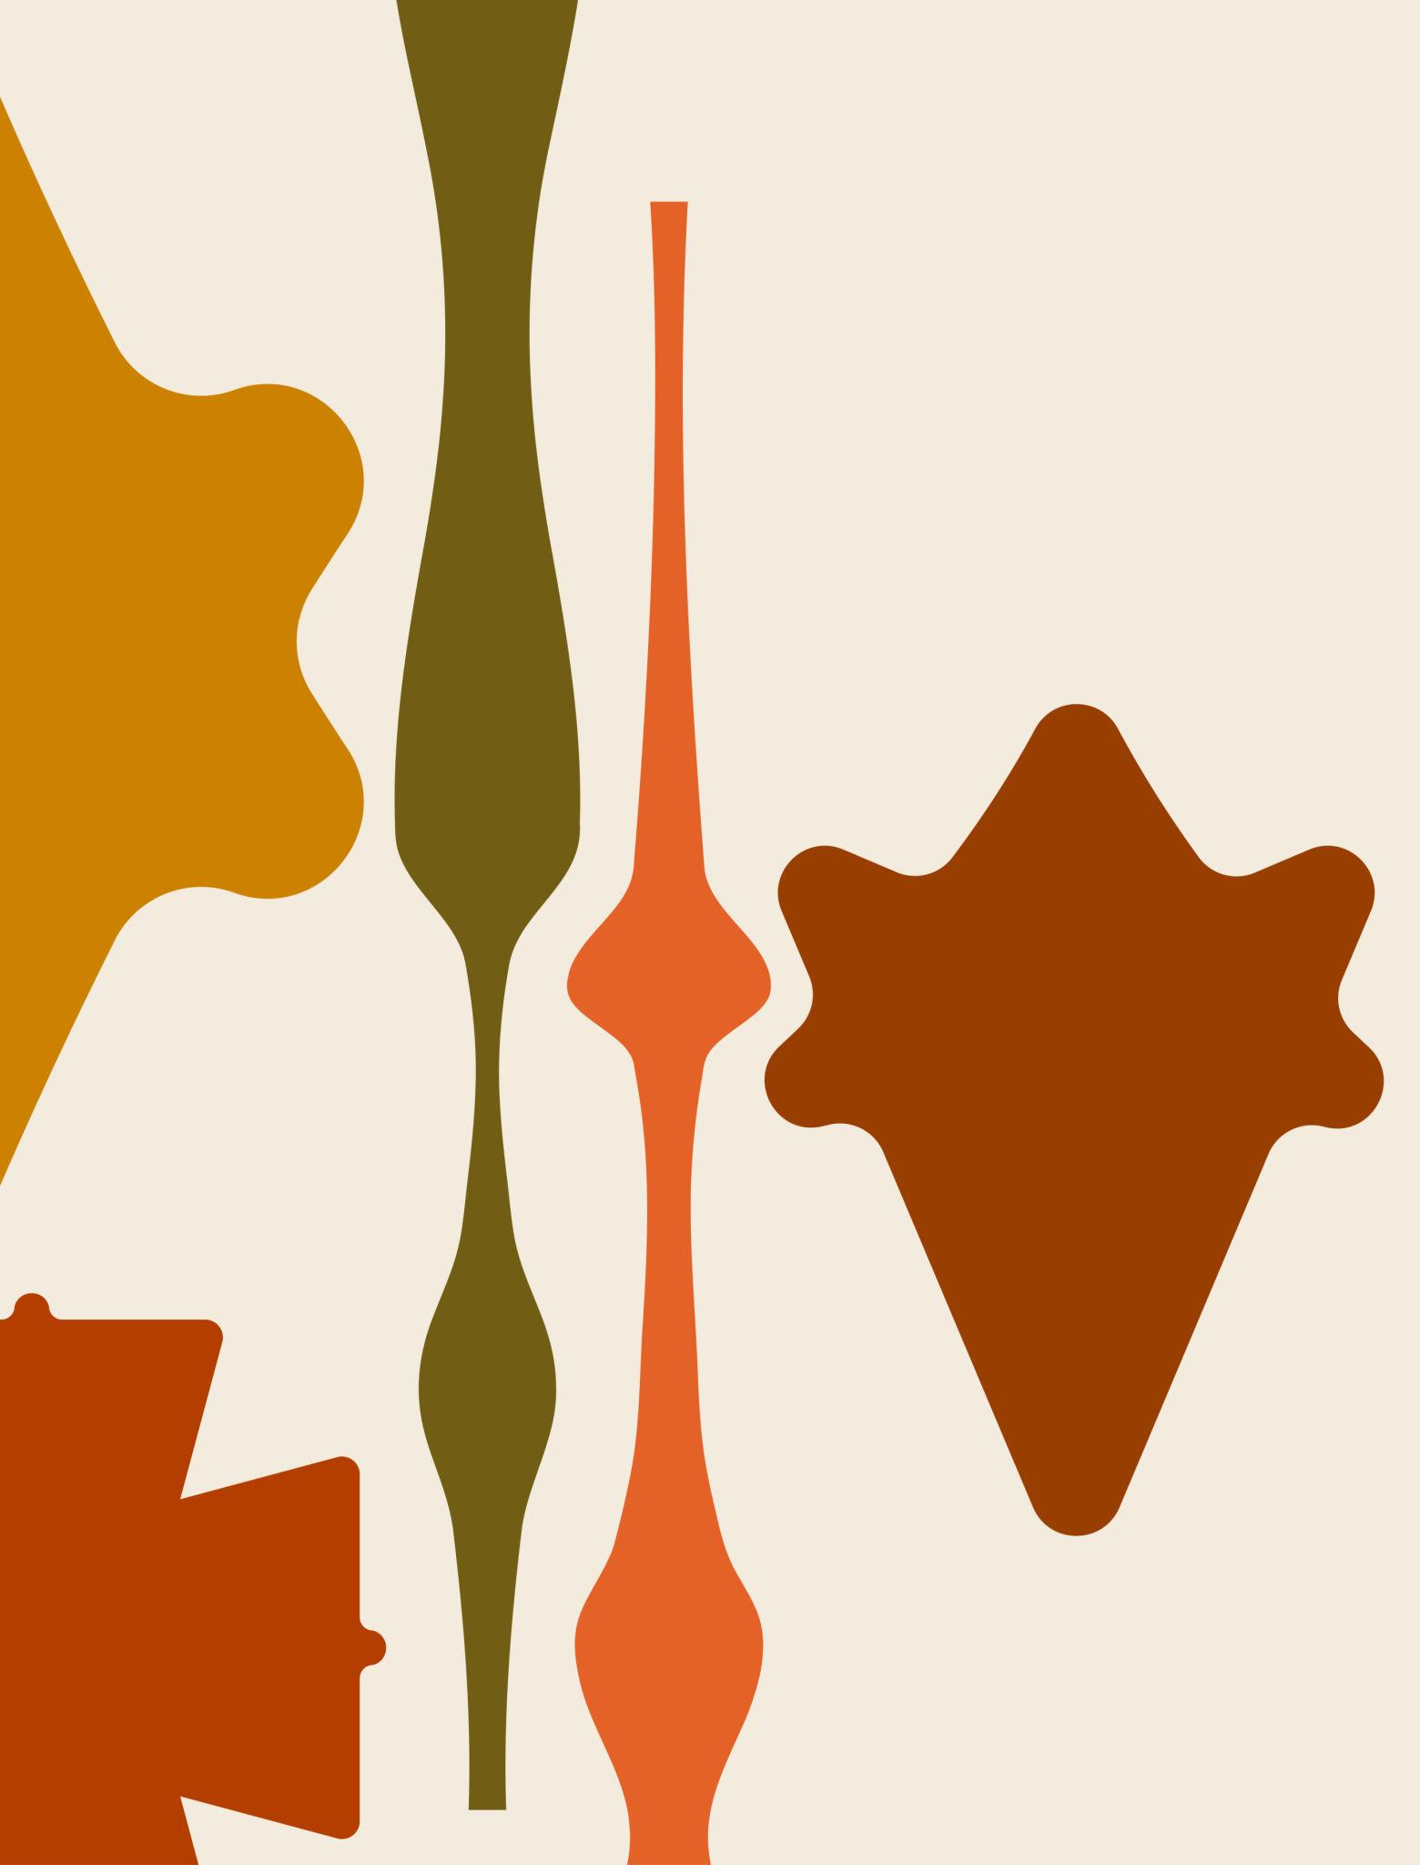
This type may combine irregular straight edges with smooth organic curves.

4. Engineering Mixed Shape
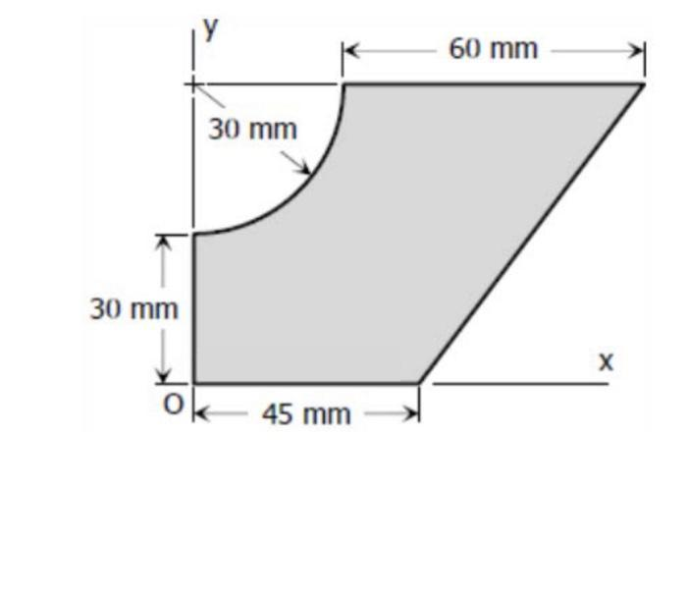
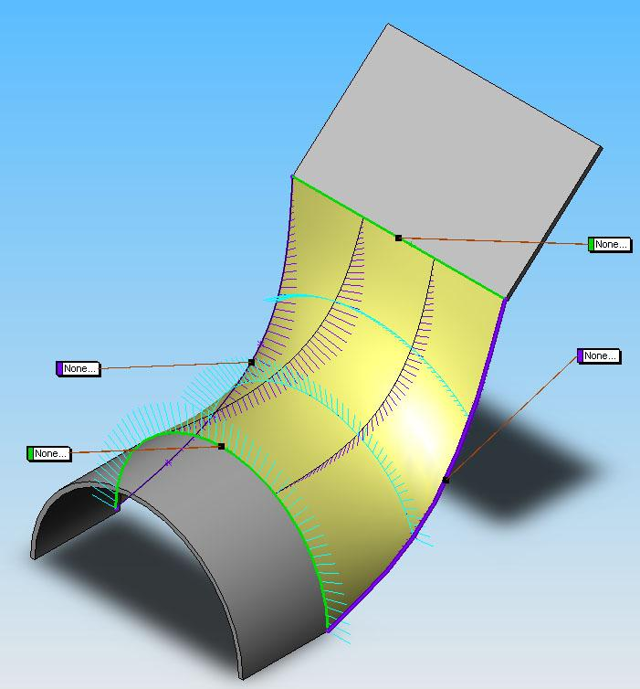
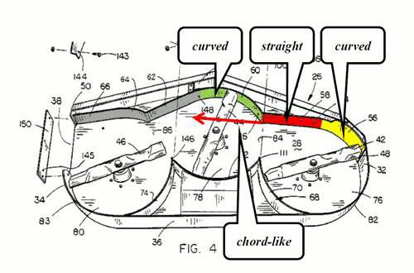
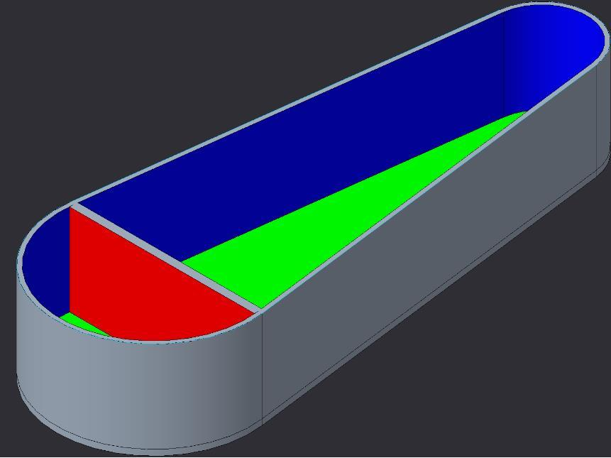
Mechanical and engineering components often contain both straight edges and circular or freeform curves.

Straight vs. Curved Boundaries
# Source: AI Source: Provided by: [Data Path: Persons Table -> ID Column: 1, Name_En Column: Motasem Essam] -> From: [ChatGPT] on [7/25/2026]
The defining feature of a mixed shape is the presence of both types of boundaries.
Straight Boundary
A────────B
Curved Boundary
A B
\_____/
Mixed Boundary
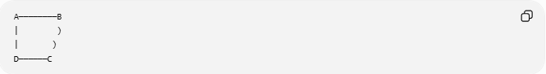
A────────B
| )
| )
D──────C
Therefore:
$$\boxed{\text{Mixed BoundaryStraight Boundary}+\text{Curved Boundary}}$$

Types of Irregular Mixed Shapes
# Source: AI Source: Provided by: [Data Path: Persons Table -> ID Column: 1, Name_En Column: Motasem Essam] -> From: [ChatGPT] on [7/25/2026]
A useful classification for your project is:

1. Polygon–Circular Mixed Shapes
# Source: AI Source: Provided by: [Data Path: Persons Table -> ID Column: 1, Name_En Column: Motasem Essam] -> From: [ChatGPT] on [7/25/2026]
Contain straight polygonal boundaries and circular arcs.



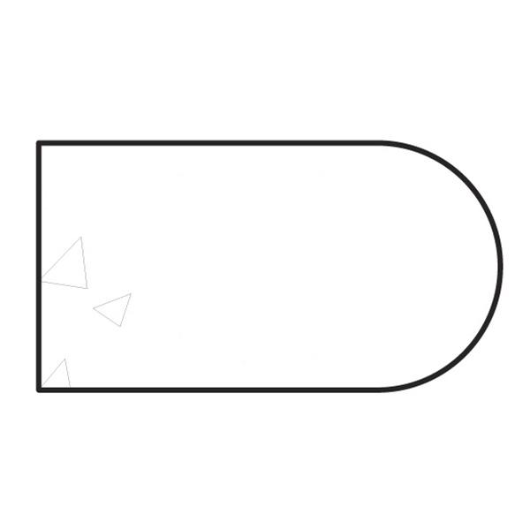

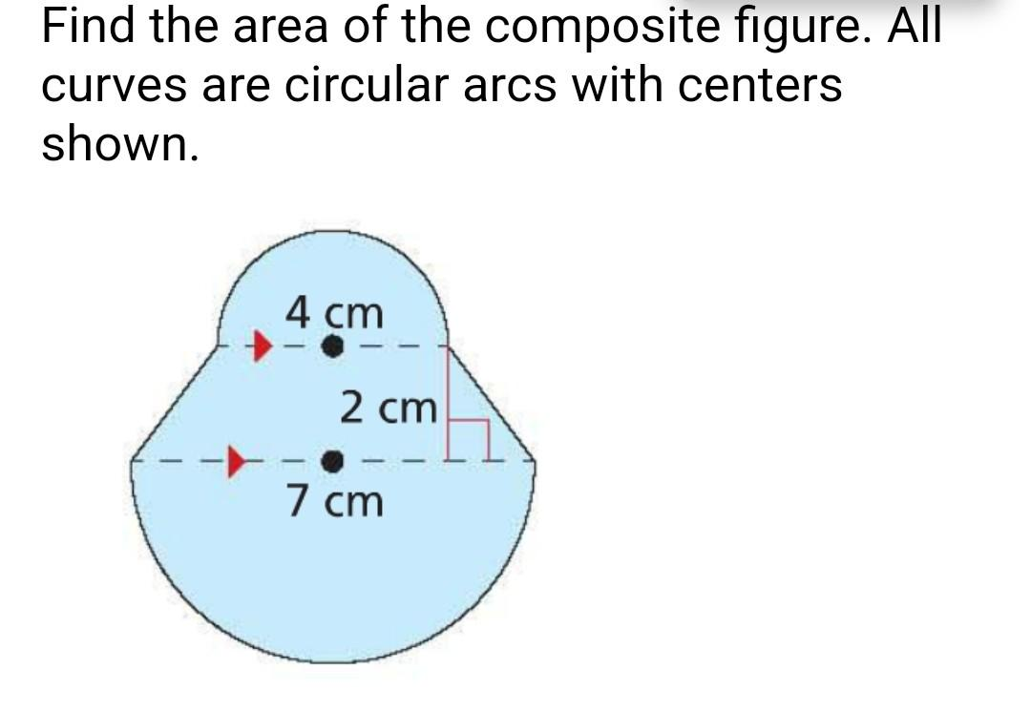

2. Polygon–Organic Mixed Shapes
# Source: AI Source: Provided by: [Data Path: Persons Table -> ID Column: 1, Name_En Column: Motasem Essam] -> From: [ChatGPT] on [7/25/2026]
Combine straight polygonal segments with irregular organic curves.
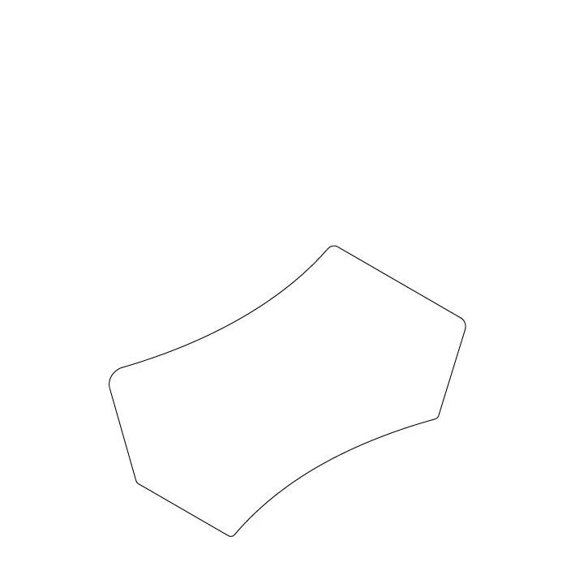

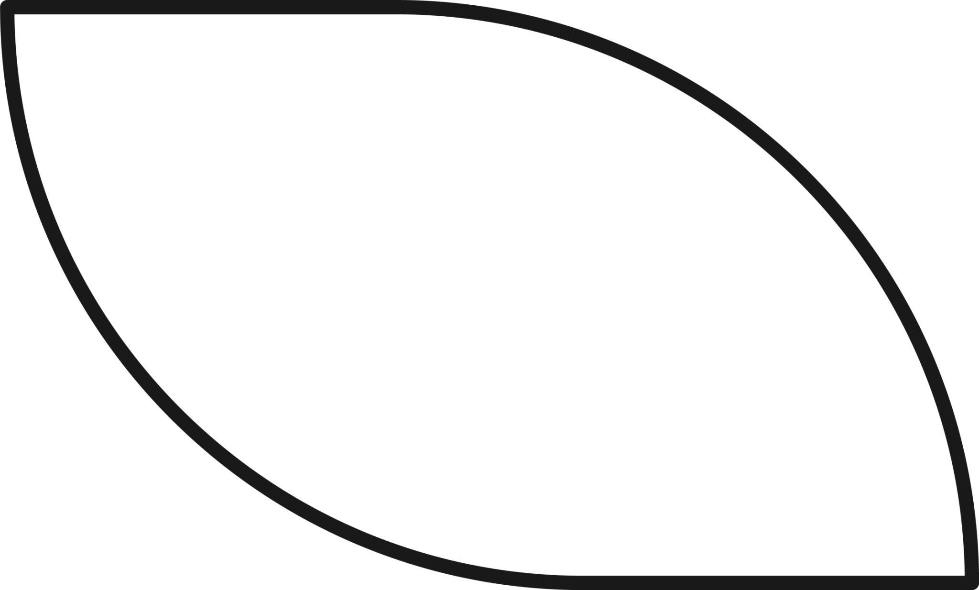
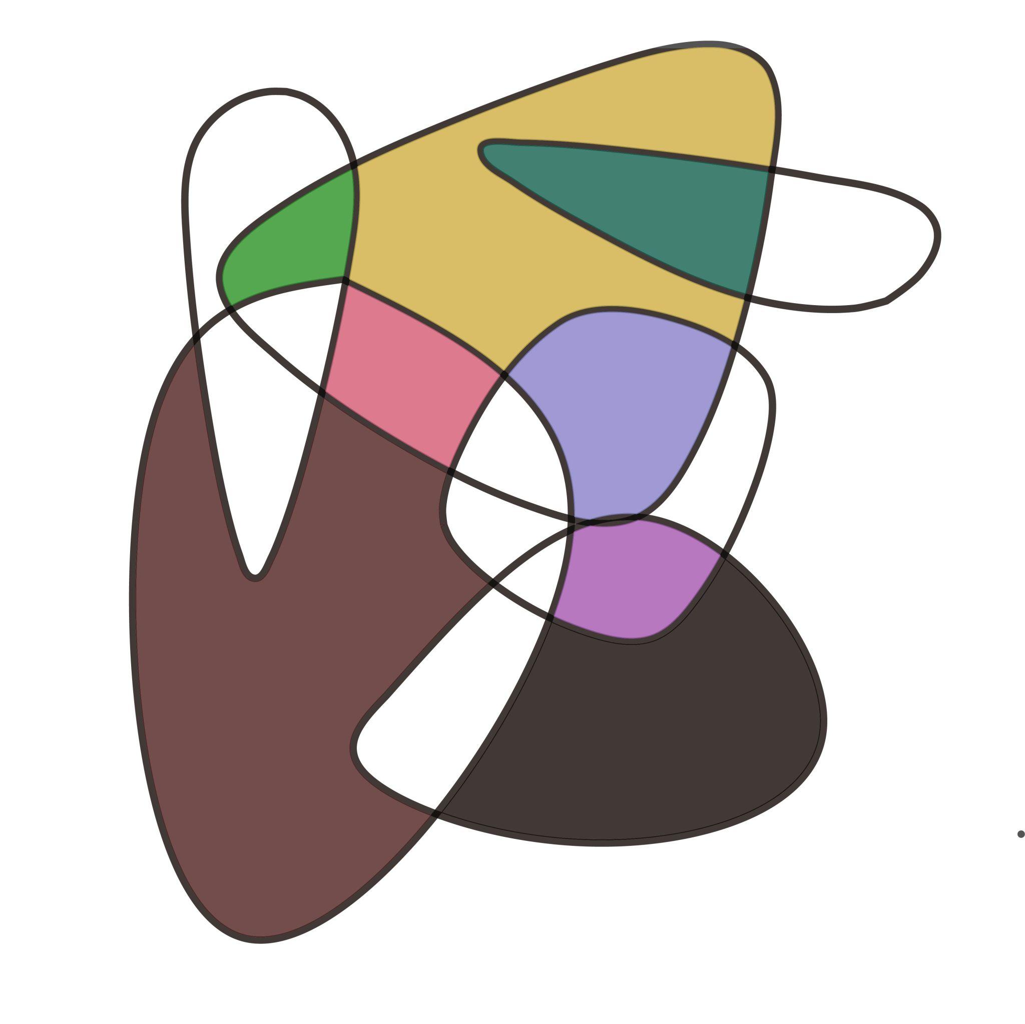

3. Rectangle–Circular Mixed Shapes
# Source: AI Source: Provided by: [Data Path: Persons Table -> ID Column: 1, Name_En Column: Motasem Essam] -> From: [ChatGPT] on [7/25/2026]
Combine rectangles with circles or semicircles.



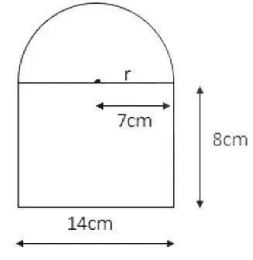
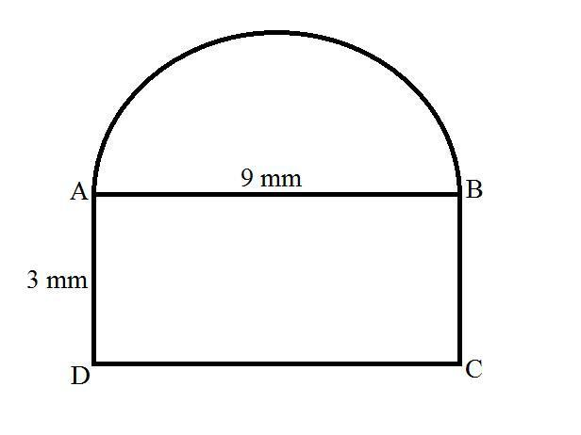

4. Triangle–Circular Mixed Shapes
# Source: AI Source: Provided by: [Data Path: Persons Table -> ID Column: 1, Name_En Column: Motasem Essam] -> From: [ChatGPT] on [7/25/2026]
Combine triangular boundaries with circular arcs.
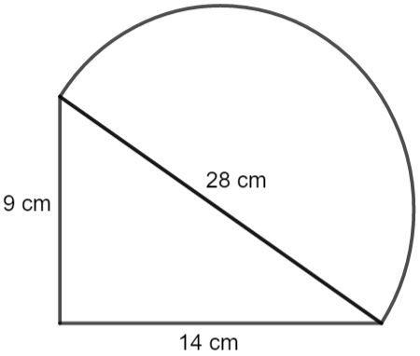
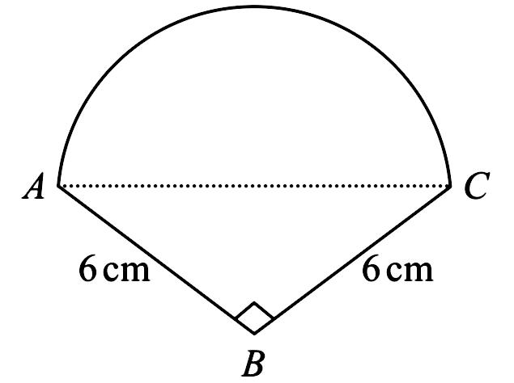
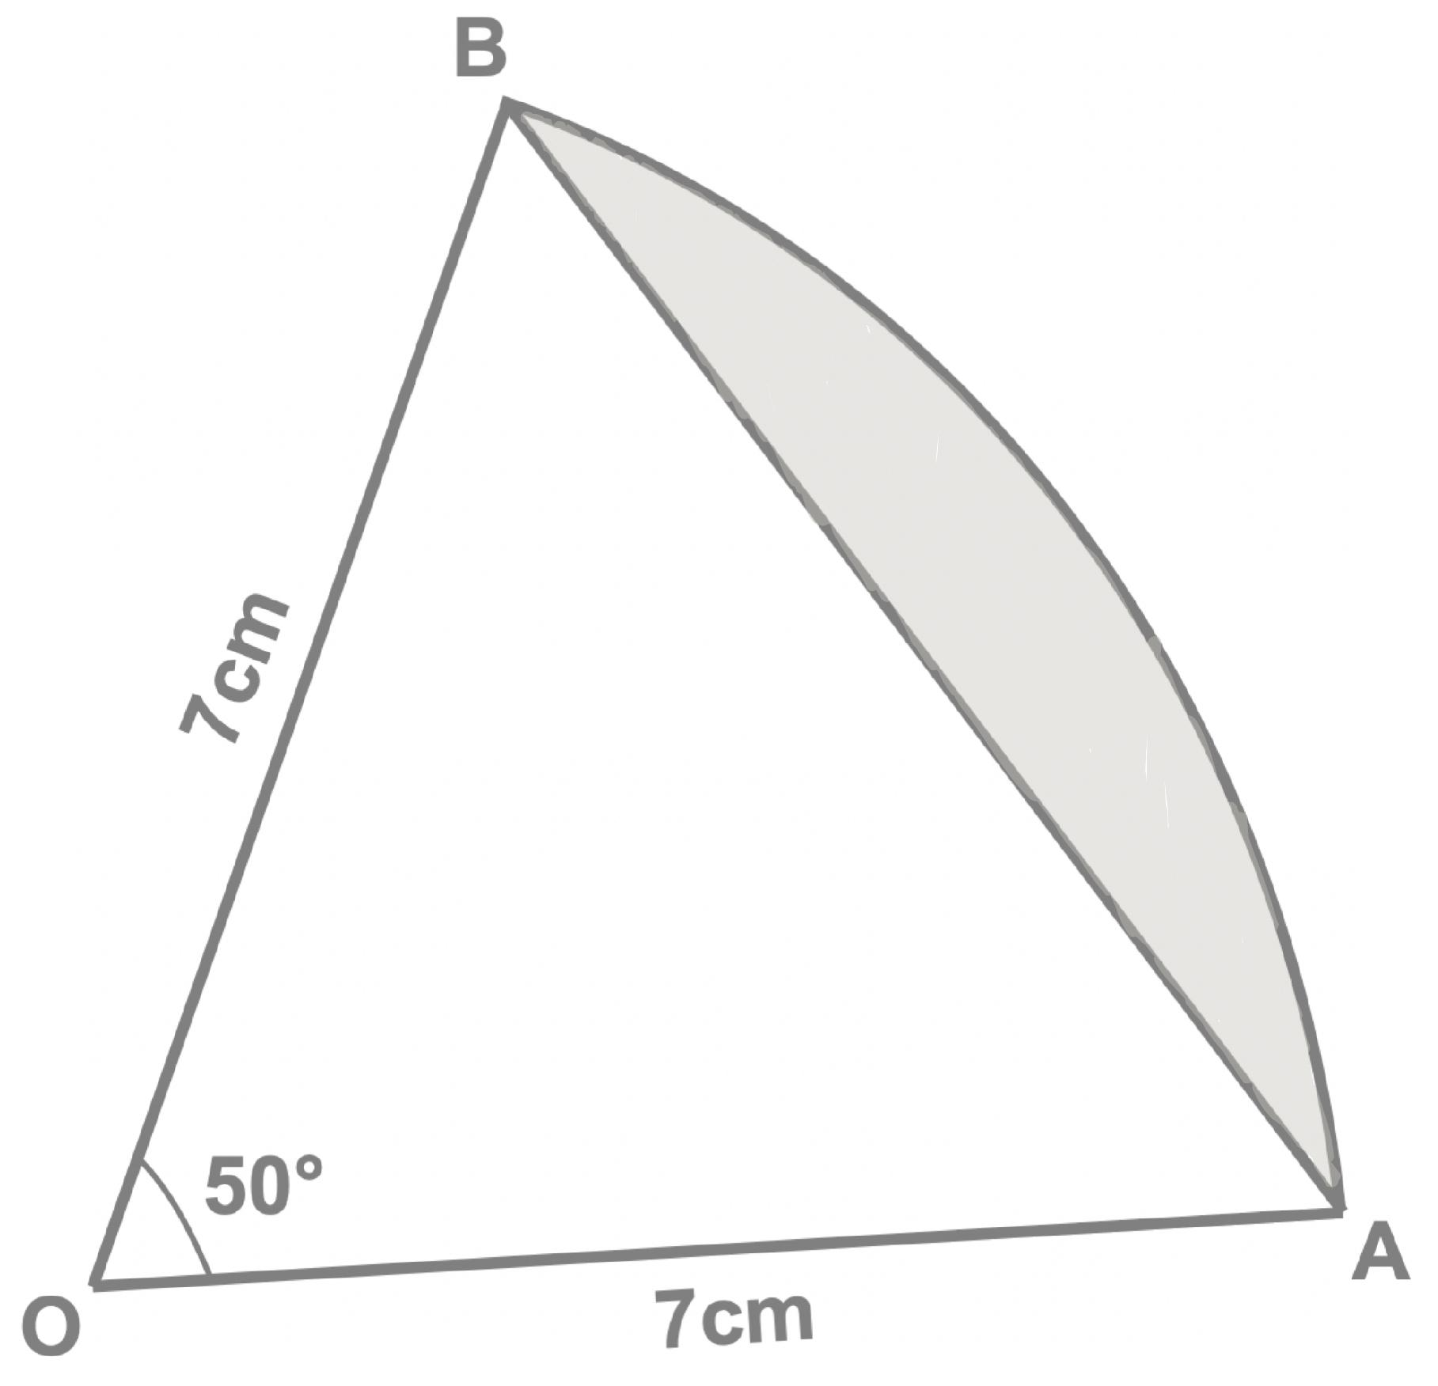
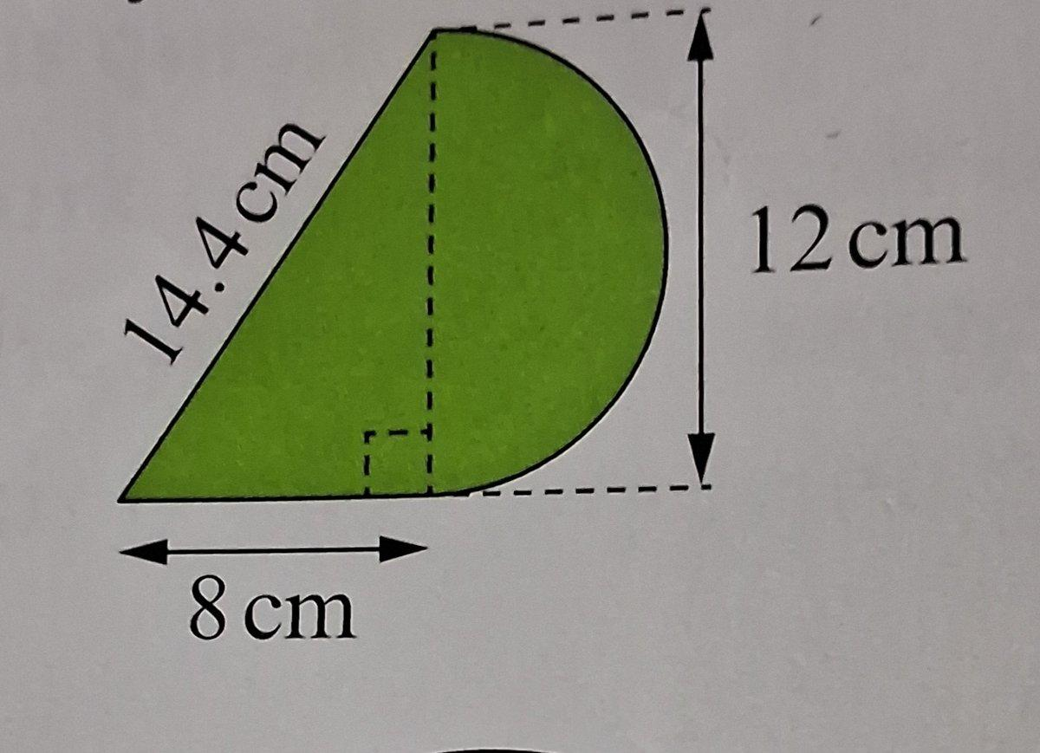
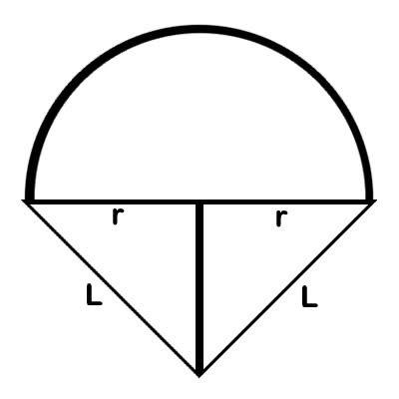
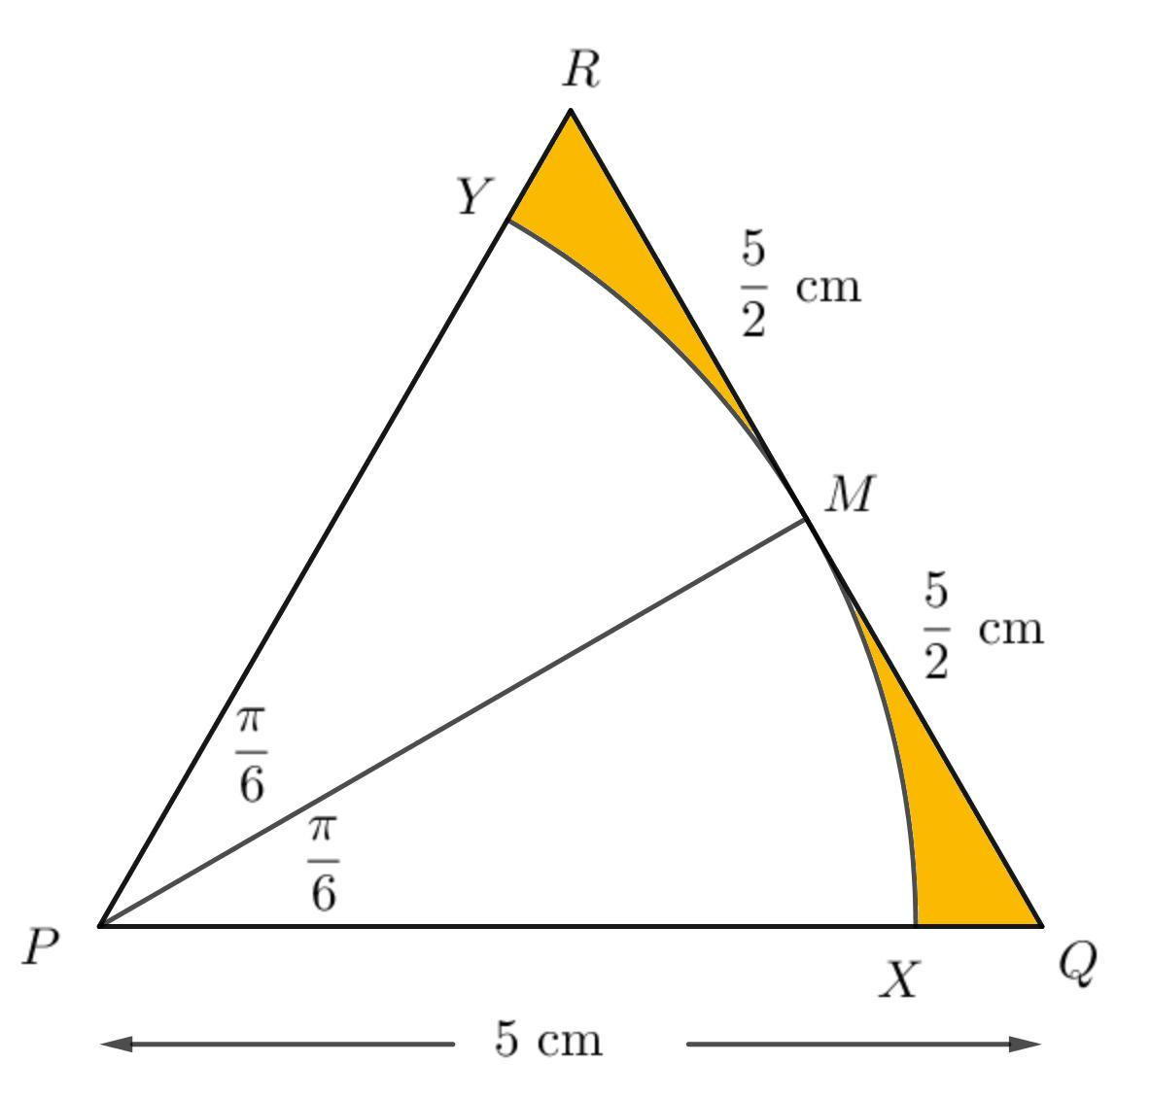
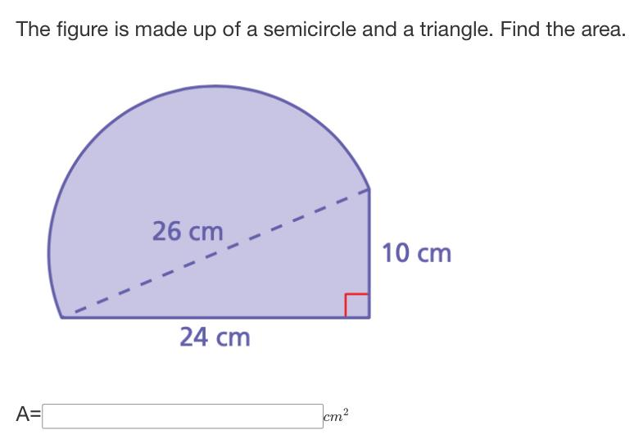

5. Freeform Mixed Shapes
# Source: AI Source: Provided by: [Data Path: Persons Table -> ID Column: 1, Name_En Column: Motasem Essam] -> From: [ChatGPT] on [7/25/2026]
Combine straight segments with freely designed curves.
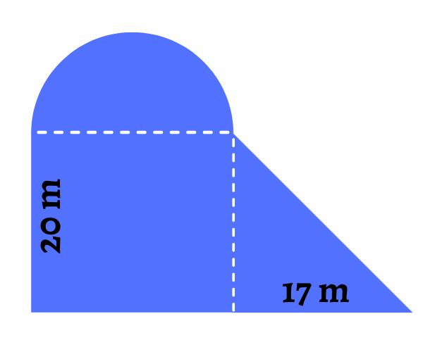
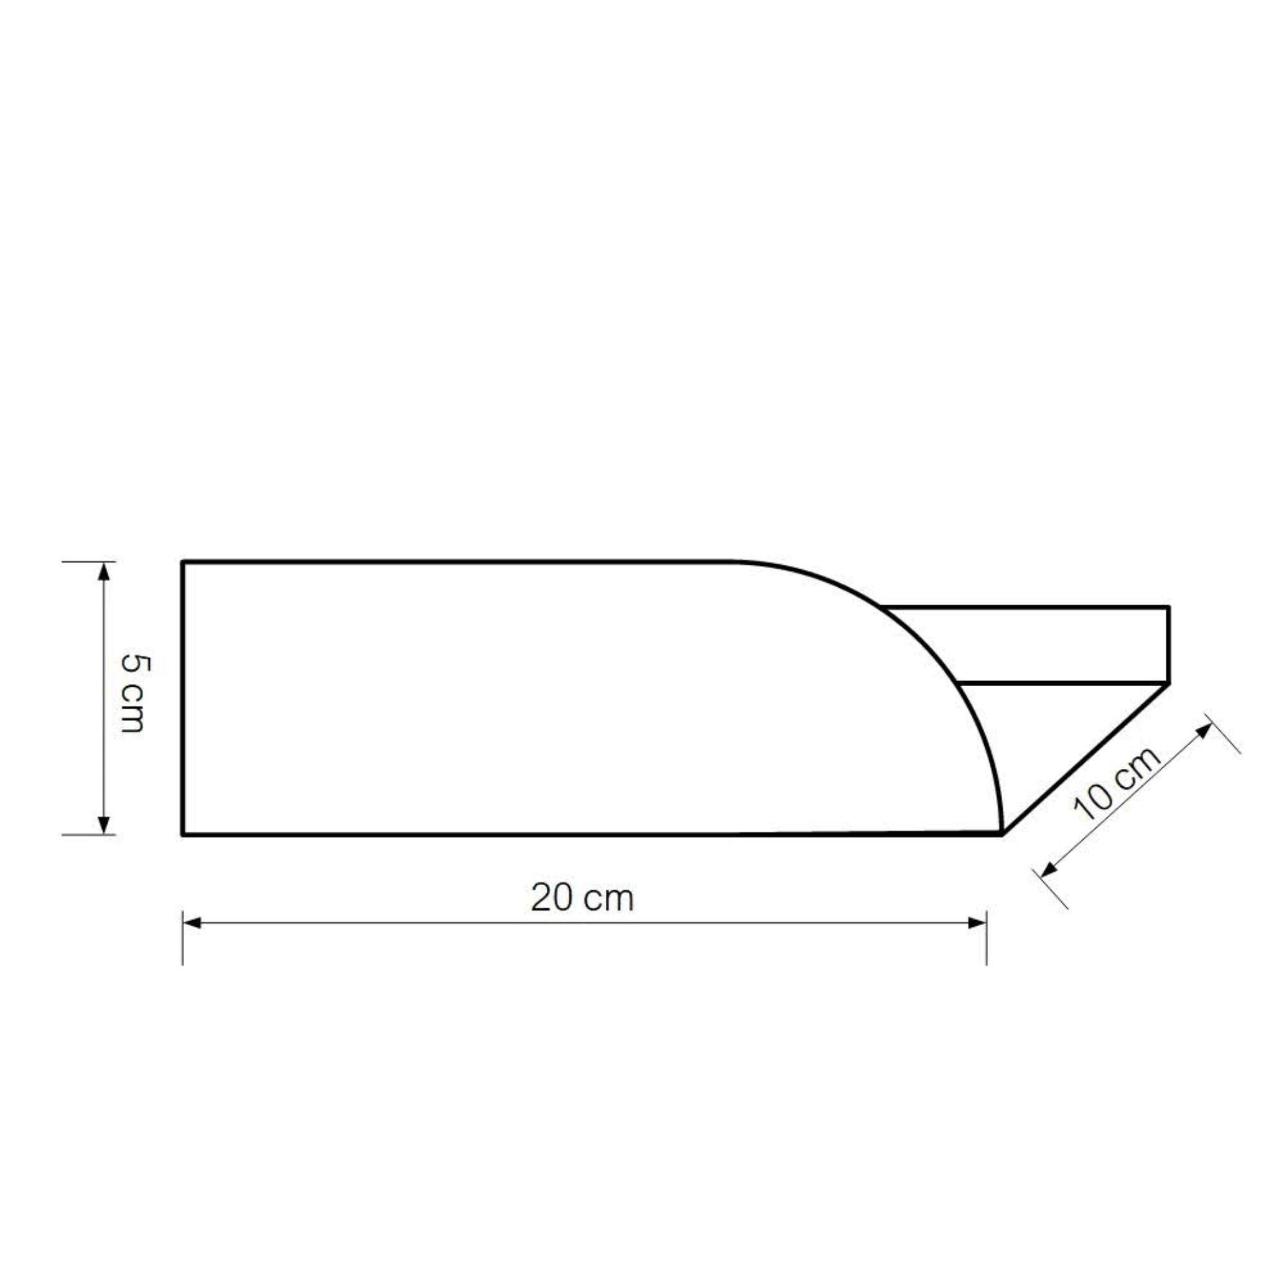
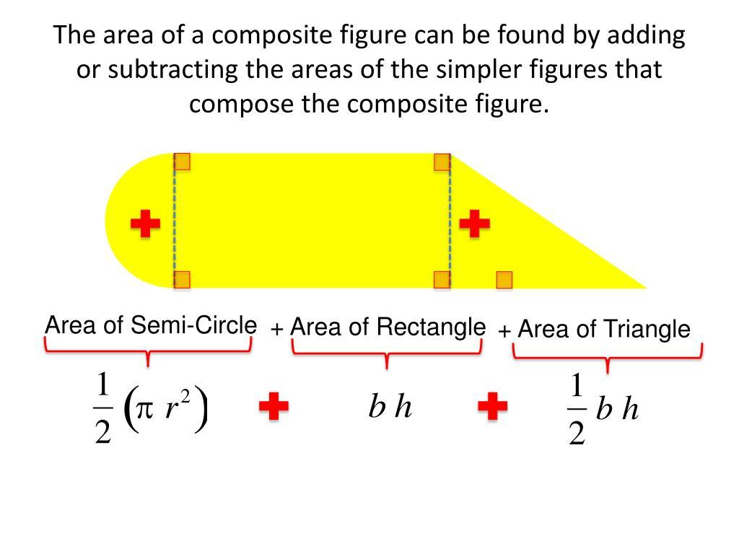

Area
# Source: AI Source: Provided by: [Data Path: Persons Table -> ID Column: 1, Name_En Column: Motasem Essam] -> From: [ChatGPT] on [7/25/2026]
An irregular mixed shape usually cannot be measured using one simple formula.
Instead, it can be decomposed into familiar shapes:
$$\boxed{A_{\text{mixed}}A_{1}+A_{2}-A_{3}}$$
For example, a rectangle with a semicircle attached can be calculated as:
$$A=A_{\text{rectangle}}+A_{\text{semicircle}}$$
Since:
$$A_{\text{rectangle}}=lw$$
and:
$$A_{\text{semicircle}}=\frac{12}{π}r^{2}$$
then:
$$\boxed{A=lw+\frac{12}{π}r^{2}}$$
For more complicated shapes, numerical integration or computational geometry may be required.

Perimeter
# Source: AI Source: Provided by: [Data Path: Persons Table -> ID Column: 1, Name_En Column: Motasem Essam] -> From: [ChatGPT] on [7/25/2026]
The perimeter is the total length of all straight and curved boundary sections:
$$\boxed{P=L_{\text{straight}}+L_{\text{curved}}}$$
For a circular arc:
$$L_{\text{arc}}=rθ$$
when (\theta) is measured in radians.
For a semicircle:
$$L_{\text{arc}}=πr$$
So the total perimeter may require adding several different lengths.

Irregular Mixed Shape vs. Irregular Curved Shape
# Source: AI Source: Provided by: [Data Path: Persons Table -> ID Column: 1, Name_En Column: Motasem Essam] -> From: [ChatGPT] on [7/25/2026]
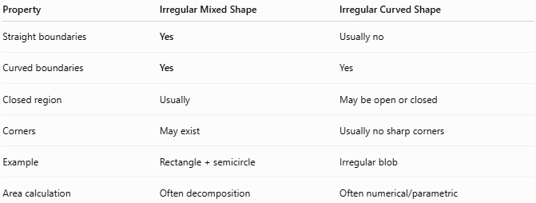
Property | Irregular Mixed Shape | Irregular Curved Shape
Straight boundaries | Yes | Usually no
Curved boundaries | Yes | Yes
Closed region | Usually | May be open or closed
Corners | May exist | Usually no sharp corners
Example | Rectangle + semicircle | Irregular blob
Area calculation | Often decomposition | Often numerical/parametric

Irregular Mixed Shape vs. Polygonal Shape
# Source: AI Source: Provided by: [Data Path: Persons Table -> ID Column: 1, Name_En Column: Motasem Essam] -> From: [ChatGPT] on [7/25/2026]
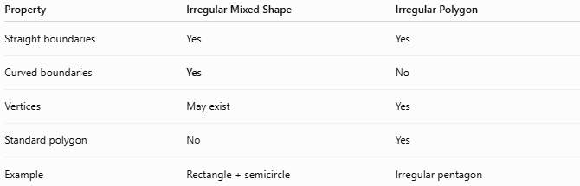
Property | Irregular Mixed Shape | Irregular Polygon
Straight boundaries | Yes | Yes
Curved boundaries | Yes | No
Vertices | May exist | Yes
Standard polygon | No | Yes
Example | Rectangle + semicircle | Irregular pentagon

Irregular Mixed Shape vs. Regular Shape
# Source: AI Source: Provided by: [Data Path: Persons Table -> ID Column: 1, Name_En Column: Motasem Essam] -> From: [ChatGPT] on [7/25/2026]
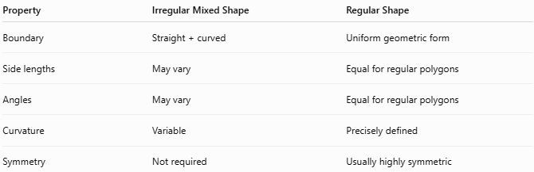
Property | Irregular Mixed Shape | Regular Shape
Boundary | Straight + curved | Uniform geometric form
Side lengths | May vary | Equal for regular polygons
Angles | May vary | Equal for regular polygons
Curvature | Variable | Precisely defined
Symmetry | Not required | Usually highly symmetric

Real-World Examples
# Source: AI Source: Provided by: [Data Path: Persons Table -> ID Column: 1, Name_En Column: Motasem Essam] -> From: [ChatGPT] on [7/25/2026]
Irregular mixed shapes occur frequently in:
- 🏠 Building floor plans
- 🚗 Automotive body panels
- ⚙️ Mechanical components
- 🪟 Windows
- 🛣️ Road layouts
- 🏞️ Land boundaries
- 🪑 Furniture designs
- 📦 Packaging
- 🖥️ Product housings
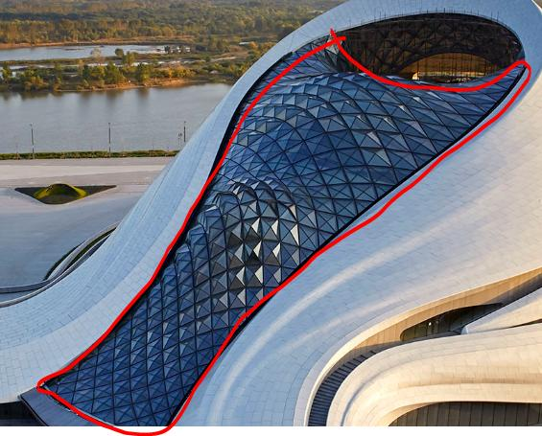
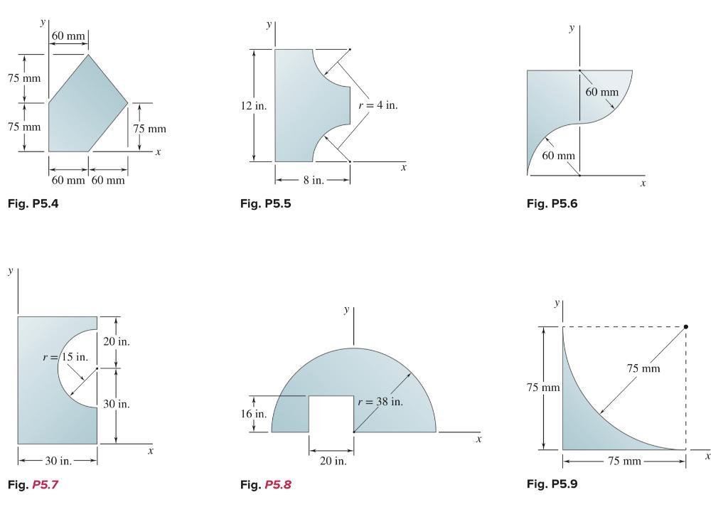
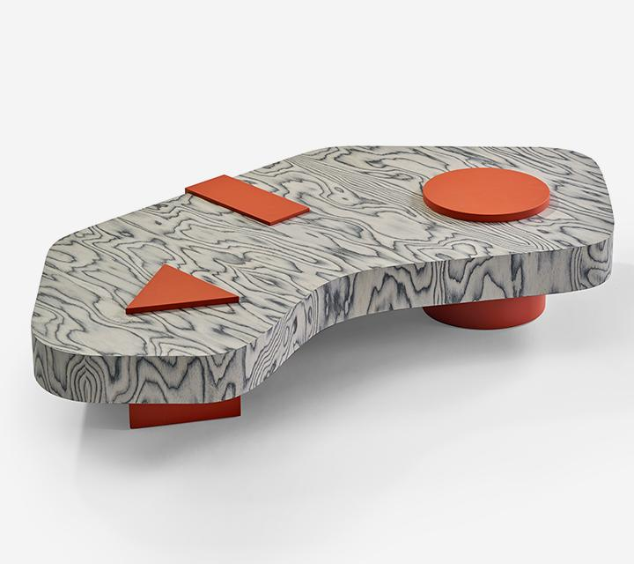
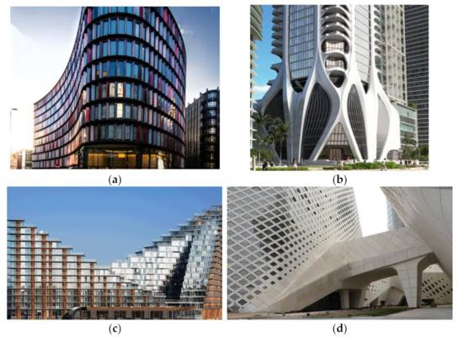
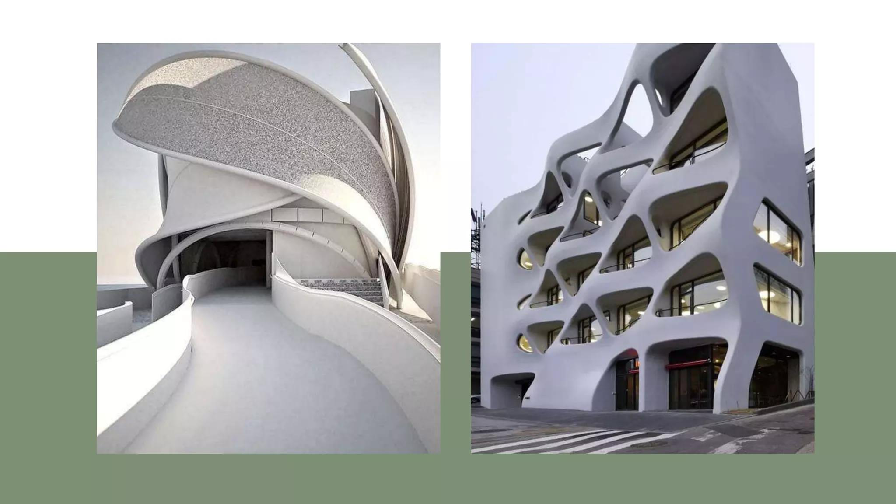
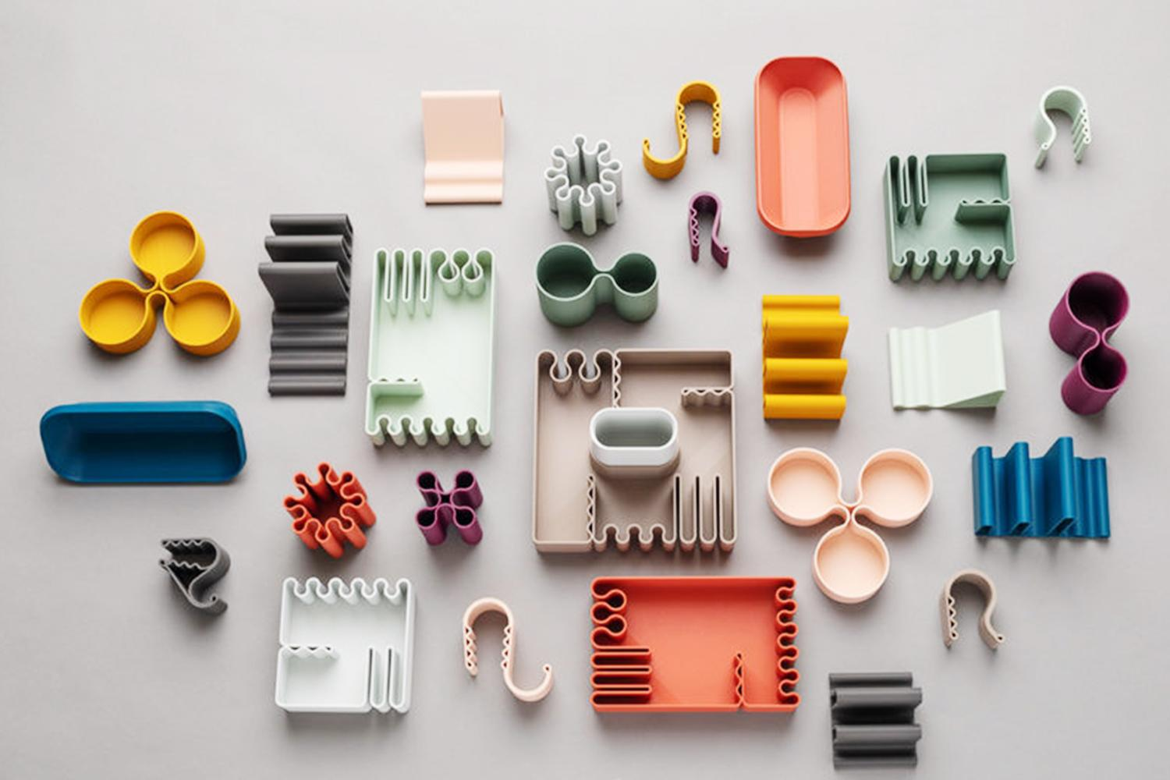

Mathematical Representation
# Source: AI Source: Provided by: [Data Path: Persons Table -> ID Column: 1, Name_En Column: Motasem Essam] -> From: [ChatGPT] on [7/25/2026]
A mixed shape can be represented using several geometric components.
For example:
$$S=S_{1}∪S_{2}∪S_{3}$$
where each $S_{i}$ may be a different geometric region.
Its boundary can be described as:
$$∂S=∂S_{\text{straight}}∪∂S_{\text{curved}}$$
For computer graphics and CAD, the boundary may be represented using:
- Line segments.
- Circular arcs.
- Bézier curves.
- Splines.
- Parametric curves.

Key Points
# Source: AI Source: Provided by: [Data Path: Persons Table -> ID Column: 1, Name_En Column: Motasem Essam] -> From: [ChatGPT] on [7/25/2026]
$$\boxed{\text{Irregular Mixed ShapeStraight Boundaries}+\text{Curved Boundaries}}$$
It is:
- Irregular.
- Usually closed.
- Made from both straight and curved boundary sections.
- Not a single standard geometric shape.
- Often measured by decomposing it into simpler shapes.

Conclusion
# Source: AI Source: Provided by: [Data Path: Persons Table -> ID Column: 1, Name_En Column: Motasem Essam] -> From: [ChatGPT] on [7/25/2026]
Irregular Mixed Shapes are irregular two-dimensional shapes whose boundaries contain both straight and curved sections. They combine characteristics of polygonal and curved shapes and may include rectangles, triangles, circular arcs, organic curves, or freeform curves. Their area and perimeter are often determined by decomposing the shape into simpler geometric parts or by using numerical and computational methods. They are common in geometry, architecture, engineering, CAD, computer graphics, product design, GIS, and real-world modeling.

